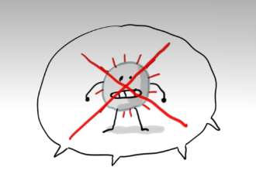
Le règlement de l'école pour combattre le virus Covid 19
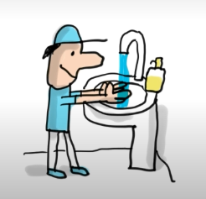
Les gestes barrières

Je dois ________________________________________________________

______________________________________________________________

______________________________________________________________

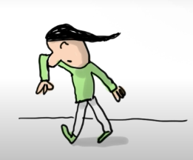

Je dois ________________________________________________________

______________________________________________________________

______________________________________________________________

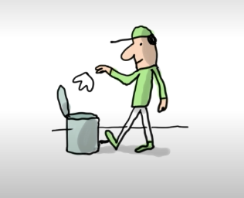

Je dois _______________________________________________________

_____________________________________________________________

_____________________________________________________________

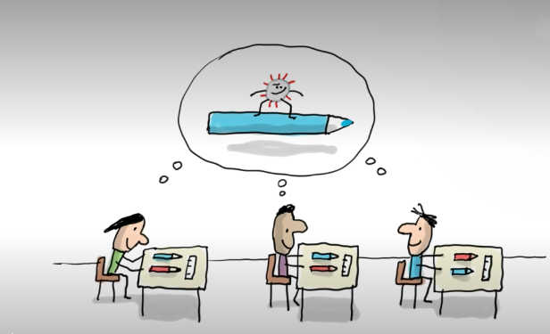

Je dois _______________________________________________________

_____________________________________________________________

_____________________________________________________________

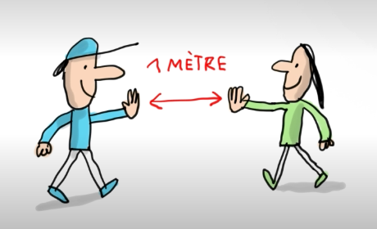

Je dois _______________________________________________________

_____________________________________________________________

_____________________________________________________________

